Воспитание культурно-гигиенических навыков у дошкольников

[](https://ok.ru/dk?cmd=PopLayerPhoto&st.layer.cmd=PopLayerPhotoOuter&st.layer.type=GROUP&st.layer.revNav=off&st.layer.limitedUi=false&st.layer.closeLayers=off&st.layer.sphotoIds=906161611828%3B906161612084%3B906161612340%3B906161612596%3B906161612852%3B906161613108%3B906161613620&st.layer.showNav=on&st.layer.photoAlbumId=57249062780980&st.layer.epm=off&st.layer.plc=mediaTopic&st.layer.photoId=906161611828&st.layer.wasRedirect%2C=off&st.layer.opl=off&st.layer.navStartPhotoId=906161611828&st.layer.navStartAlbumId%2C=57249062780980&st.layer.sbd=off&st.cmd=userMain&st._aid=GroupTopicLayer_openPhotoLayer)

[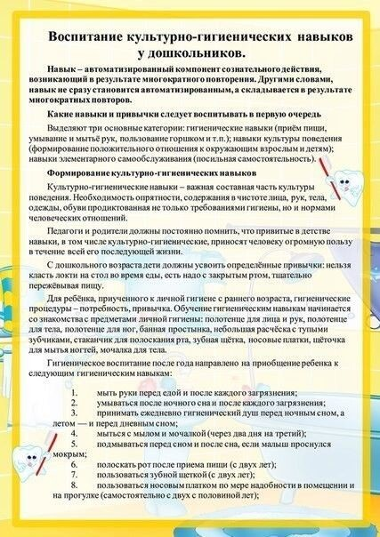](https://ok.ru/dk?cmd=PopLayerPhoto&st.layer.cmd=PopLayerPhotoOuter&st.layer.type=GROUP&st.layer.revNav=off&st.layer.limitedUi=false&st.layer.closeLayers=off&st.layer.sphotoIds=906161611828%3B906161612084%3B906161612340%3B906161612596%3B906161612852%3B906161613108%3B906161613620&st.layer.showNav=on&st.layer.photoAlbumId=57249062780980&st.layer.epm=off&st.layer.plc=mediaTopic&st.layer.photoId=906161612084&st.layer.wasRedirect%2C=off&st.layer.opl=off&st.layer.navStartPhotoId=906161612084&st.layer.navStartAlbumId%2C=57249062780980&st.layer.sbd=off&st.cmd=userMain&st._aid=GroupTopicLayer_openPhotoLayer)

[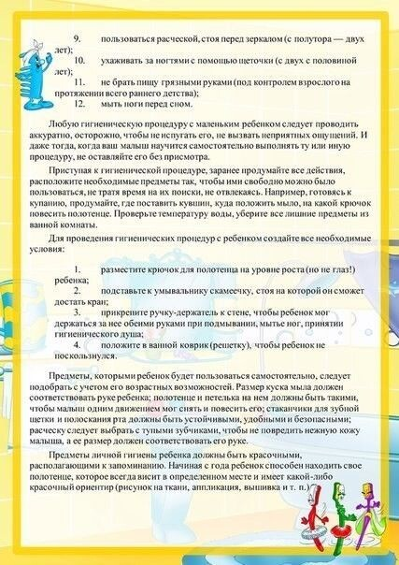](https://ok.ru/dk?cmd=PopLayerPhoto&st.layer.cmd=PopLayerPhotoOuter&st.layer.type=GROUP&st.layer.revNav=off&st.layer.limitedUi=false&st.layer.closeLayers=off&st.layer.sphotoIds=906161611828%3B906161612084%3B906161612340%3B906161612596%3B906161612852%3B906161613108%3B906161613620&st.layer.showNav=on&st.layer.photoAlbumId=57249062780980&st.layer.epm=off&st.layer.plc=mediaTopic&st.layer.photoId=906161612340&st.layer.wasRedirect%2C=off&st.layer.opl=off&st.layer.navStartPhotoId=906161612340&st.layer.navStartAlbumId%2C=57249062780980&st.layer.sbd=off&st.cmd=userMain&st._aid=GroupTopicLayer_openPhotoLayer)

[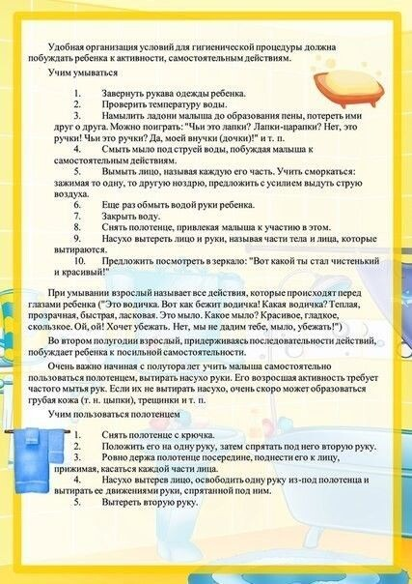](https://ok.ru/dk?cmd=PopLayerPhoto&st.layer.cmd=PopLayerPhotoOuter&st.layer.type=GROUP&st.layer.revNav=off&st.layer.limitedUi=false&st.layer.closeLayers=off&st.layer.sphotoIds=906161611828%3B906161612084%3B906161612340%3B906161612596%3B906161612852%3B906161613108%3B906161613620&st.layer.showNav=on&st.layer.photoAlbumId=57249062780980&st.layer.epm=off&st.layer.plc=mediaTopic&st.layer.photoId=906161612596&st.layer.wasRedirect%2C=off&st.layer.opl=off&st.layer.navStartPhotoId=906161612596&st.layer.navStartAlbumId%2C=57249062780980&st.layer.sbd=off&st.cmd=userMain&st._aid=GroupTopicLayer_openPhotoLayer)

[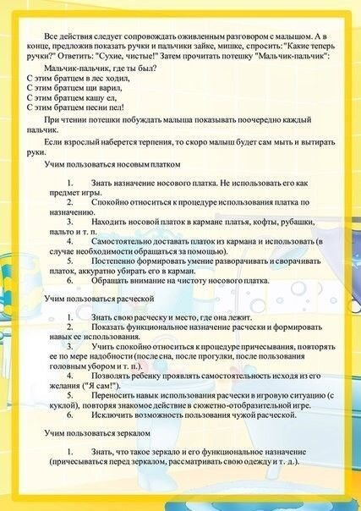](https://ok.ru/dk?cmd=PopLayerPhoto&st.layer.cmd=PopLayerPhotoOuter&st.layer.type=GROUP&st.layer.revNav=off&st.layer.limitedUi=false&st.layer.closeLayers=off&st.layer.sphotoIds=906161611828%3B906161612084%3B906161612340%3B906161612596%3B906161612852%3B906161613108%3B906161613620&st.layer.showNav=on&st.layer.photoAlbumId=57249062780980&st.layer.epm=off&st.layer.plc=mediaTopic&st.layer.photoId=906161612852&st.layer.wasRedirect%2C=off&st.layer.opl=off&st.layer.navStartPhotoId=906161612852&st.layer.navStartAlbumId%2C=57249062780980&st.layer.sbd=off&st.cmd=userMain&st._aid=GroupTopicLayer_openPhotoLayer)

[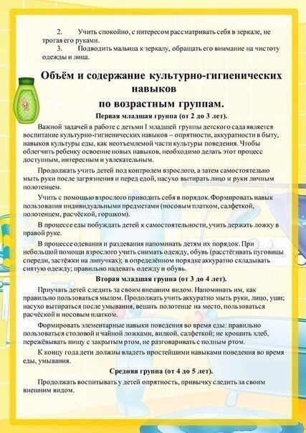](https://ok.ru/dk?cmd=PopLayerPhoto&st.layer.cmd=PopLayerPhotoOuter&st.layer.type=GROUP&st.layer.revNav=off&st.layer.limitedUi=false&st.layer.closeLayers=off&st.layer.sphotoIds=906161611828%3B906161612084%3B906161612340%3B906161612596%3B906161612852%3B906161613108%3B906161613620&st.layer.showNav=on&st.layer.photoAlbumId=57249062780980&st.layer.epm=off&st.layer.plc=mediaTopic&st.layer.photoId=906161613108&st.layer.wasRedirect%2C=off&st.layer.opl=off&st.layer.navStartPhotoId=906161613108&st.layer.navStartAlbumId%2C=57249062780980&st.layer.sbd=off&st.cmd=userMain&st._aid=GroupTopicLayer_openPhotoLayer)

[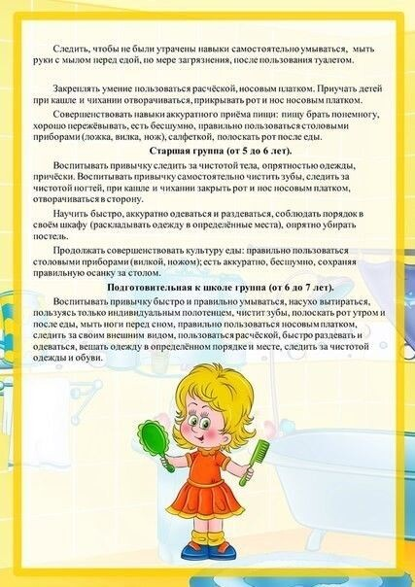](https://ok.ru/dk?cmd=PopLayerPhoto&st.layer.cmd=PopLayerPhotoOuter&st.layer.type=GROUP&st.layer.revNav=off&st.layer.limitedUi=false&st.layer.closeLayers=off&st.layer.sphotoIds=906161611828%3B906161612084%3B906161612340%3B906161612596%3B906161612852%3B906161613108%3B906161613620&st.layer.showNav=on&st.layer.photoAlbumId=57249062780980&st.layer.epm=off&st.layer.plc=mediaTopic&st.layer.photoId=906161613620&st.layer.wasRedirect%2C=off&st.layer.opl=off&st.layer.navStartPhotoId=906161613620&st.layer.navStartAlbumId%2C=57249062780980&st.layer.sbd=off&st.cmd=userMain&st._aid=GroupTopicLayer_openPhotoLayer)

* [Комментировать0](https://ok.ru/discussions/1/57249006420020/151810568952628)
* Поделиться17
* Класс92