Возрастные особенности детей 3-4 лет.

[](https://ok.ru/dk?cmd=PopLayerPhoto&st.layer.cmd=PopLayerPhotoOuter&st.layer.type=GROUP&st.layer.revNav=off&st.layer.limitedUi=false&st.layer.closeLayers=off&st.layer.sphotoIds=906107783220%3B906107783476%3B906107783732%3B906107783988%3B906107784244%3B906107784500%3B906107784756&st.layer.showNav=on&st.layer.photoAlbumId=57249062780980&st.layer.epm=off&st.layer.plc=mediaTopic&st.layer.photoId=906107783220&st.layer.wasRedirect%2C=off&st.layer.opl=off&st.layer.navStartPhotoId=906107783220&st.layer.navStartAlbumId%2C=57249062780980&st.layer.sbd=off&st.cmd=userMain&st._aid=GroupTopicLayer_openPhotoLayer)

[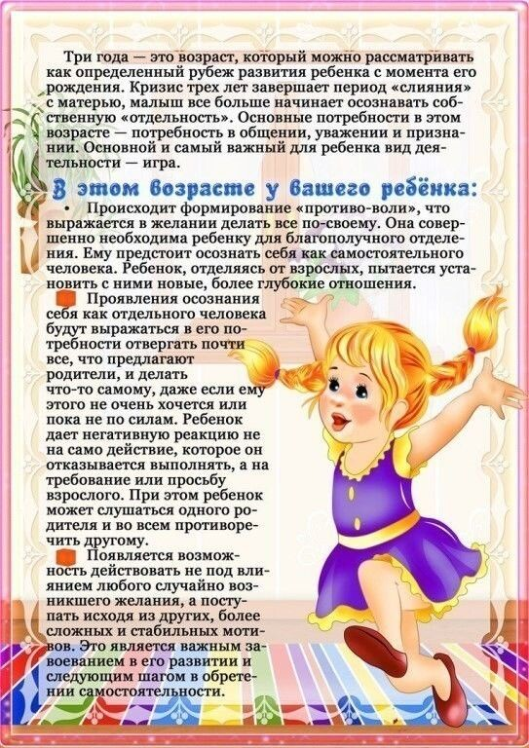](https://ok.ru/dk?cmd=PopLayerPhoto&st.layer.cmd=PopLayerPhotoOuter&st.layer.type=GROUP&st.layer.revNav=off&st.layer.limitedUi=false&st.layer.closeLayers=off&st.layer.sphotoIds=906107783220%3B906107783476%3B906107783732%3B906107783988%3B906107784244%3B906107784500%3B906107784756&st.layer.showNav=on&st.layer.photoAlbumId=57249062780980&st.layer.epm=off&st.layer.plc=mediaTopic&st.layer.photoId=906107783476&st.layer.wasRedirect%2C=off&st.layer.opl=off&st.layer.navStartPhotoId=906107783476&st.layer.navStartAlbumId%2C=57249062780980&st.layer.sbd=off&st.cmd=userMain&st._aid=GroupTopicLayer_openPhotoLayer)

[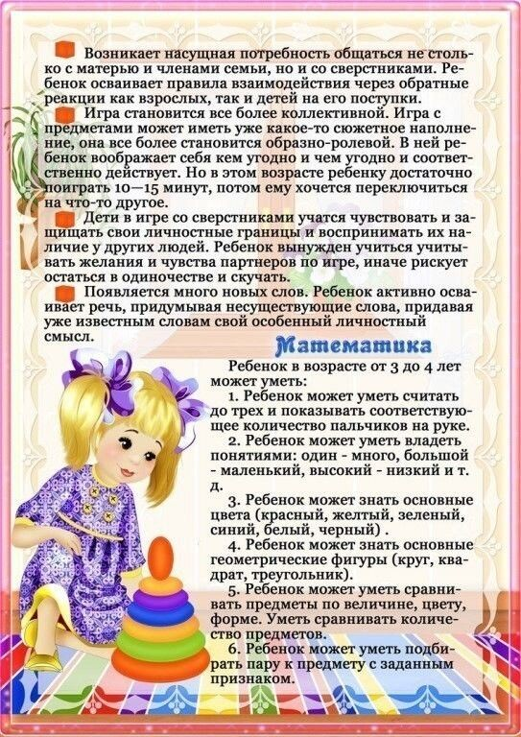](https://ok.ru/dk?cmd=PopLayerPhoto&st.layer.cmd=PopLayerPhotoOuter&st.layer.type=GROUP&st.layer.revNav=off&st.layer.limitedUi=false&st.layer.closeLayers=off&st.layer.sphotoIds=906107783220%3B906107783476%3B906107783732%3B906107783988%3B906107784244%3B906107784500%3B906107784756&st.layer.showNav=on&st.layer.photoAlbumId=57249062780980&st.layer.epm=off&st.layer.plc=mediaTopic&st.layer.photoId=906107783732&st.layer.wasRedirect%2C=off&st.layer.opl=off&st.layer.navStartPhotoId=906107783732&st.layer.navStartAlbumId%2C=57249062780980&st.layer.sbd=off&st.cmd=userMain&st._aid=GroupTopicLayer_openPhotoLayer)

[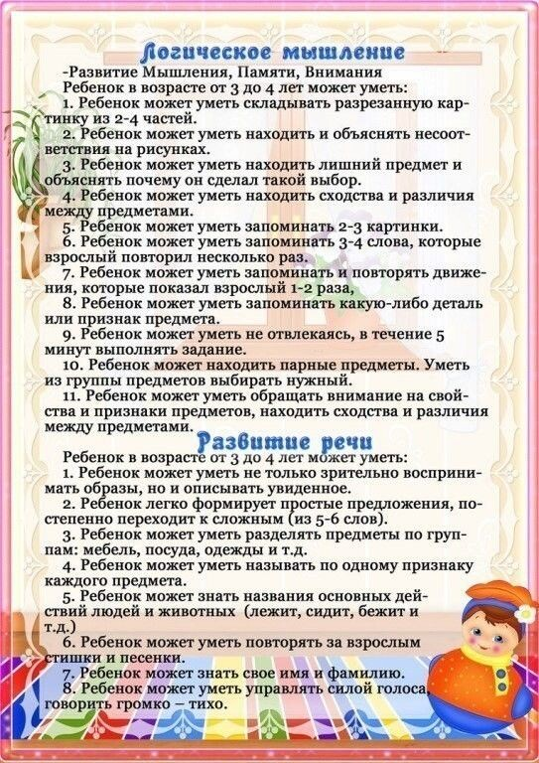](https://ok.ru/dk?cmd=PopLayerPhoto&st.layer.cmd=PopLayerPhotoOuter&st.layer.type=GROUP&st.layer.revNav=off&st.layer.limitedUi=false&st.layer.closeLayers=off&st.layer.sphotoIds=906107783220%3B906107783476%3B906107783732%3B906107783988%3B906107784244%3B906107784500%3B906107784756&st.layer.showNav=on&st.layer.photoAlbumId=57249062780980&st.layer.epm=off&st.layer.plc=mediaTopic&st.layer.photoId=906107783988&st.layer.wasRedirect%2C=off&st.layer.opl=off&st.layer.navStartPhotoId=906107783988&st.layer.navStartAlbumId%2C=57249062780980&st.layer.sbd=off&st.cmd=userMain&st._aid=GroupTopicLayer_openPhotoLayer)

[](https://ok.ru/dk?cmd=PopLayerPhoto&st.layer.cmd=PopLayerPhotoOuter&st.layer.type=GROUP&st.layer.revNav=off&st.layer.limitedUi=false&st.layer.closeLayers=off&st.layer.sphotoIds=906107783220%3B906107783476%3B906107783732%3B906107783988%3B906107784244%3B906107784500%3B906107784756&st.layer.showNav=on&st.layer.photoAlbumId=57249062780980&st.layer.epm=off&st.layer.plc=mediaTopic&st.layer.photoId=906107784244&st.layer.wasRedirect%2C=off&st.layer.opl=off&st.layer.navStartPhotoId=906107784244&st.layer.navStartAlbumId%2C=57249062780980&st.layer.sbd=off&st.cmd=userMain&st._aid=GroupTopicLayer_openPhotoLayer)

[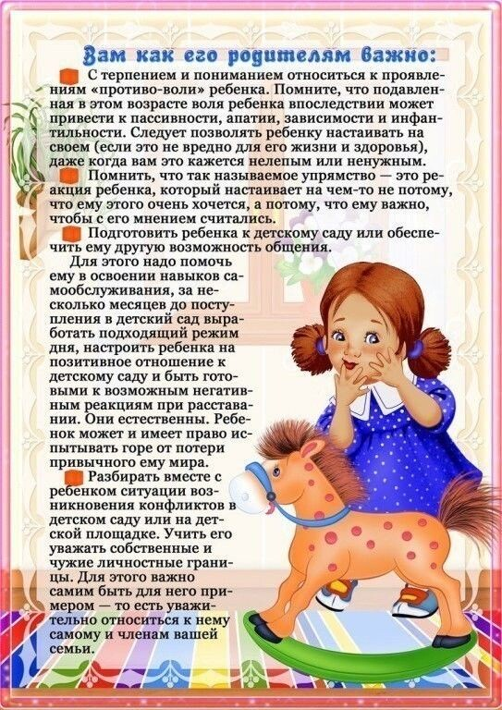](https://ok.ru/dk?cmd=PopLayerPhoto&st.layer.cmd=PopLayerPhotoOuter&st.layer.type=GROUP&st.layer.revNav=off&st.layer.limitedUi=false&st.layer.closeLayers=off&st.layer.sphotoIds=906107783220%3B906107783476%3B906107783732%3B906107783988%3B906107784244%3B906107784500%3B906107784756&st.layer.showNav=on&st.layer.photoAlbumId=57249062780980&st.layer.epm=off&st.layer.plc=mediaTopic&st.layer.photoId=906107784500&st.layer.wasRedirect%2C=off&st.layer.opl=off&st.layer.navStartPhotoId=906107784500&st.layer.navStartAlbumId%2C=57249062780980&st.layer.sbd=off&st.cmd=userMain&st._aid=GroupTopicLayer_openPhotoLayer)

[](https://ok.ru/dk?cmd=PopLayerPhoto&st.layer.cmd=PopLayerPhotoOuter&st.layer.type=GROUP&st.layer.revNav=off&st.layer.limitedUi=false&st.layer.closeLayers=off&st.layer.sphotoIds=906107783220%3B906107783476%3B906107783732%3B906107783988%3B906107784244%3B906107784500%3B906107784756&st.layer.showNav=on&st.layer.photoAlbumId=57249062780980&st.layer.epm=off&st.layer.plc=mediaTopic&st.layer.photoId=906107784756&st.layer.wasRedirect%2C=off&st.layer.opl=off&st.layer.navStartPhotoId=906107784756&st.layer.navStartAlbumId%2C=57249062780980&st.layer.sbd=off&st.cmd=userMain&st._aid=GroupTopicLayer_openPhotoLayer)